Experiment 4: Logistic Regression (From Scratch, Gradient Descent)
ED408 — Statistical / Supervised Machine Learning Lab
Aim: Implement Logistic Regression from scratch using batch gradient descent to minimize binary cross-entropy loss.
Dataset Used: BSDS500 (Berkeley Segmentation Data Set) ships as natural images with hand-annotated object-boundary ground truth, not a tabular dataset. It was converted into a tabular binary-classification dataset (data/bsds_features.csv, built by scripts/build_dataset.py): one row per sampled pixel from all 200 BSDS500 training images, 10 features (R, G, B, gray, grad_mag, grad_dir, laplacian, local_std, x_norm, y_norm) capturing colour, gradient, texture and position, and label is_edge (1 if a majority of 6 human annotators marked the pixel as a segment boundary, else 0). 24,000 rows total, perfectly balanced (12,000 / 12,000). This same dataset is reused, unchanged, for every question in this lab.
Theory
Logistic Regression models P(y=1|x) = sigma(w.x + b) where sigma is the logistic sigmoid. Parameters are learned by minimizing the binary cross-entropy loss via gradient descent: at every iteration the gradient of the loss w.r.t. w is computed over the whole training set (batch GD) and w is updated as w := w - lr * grad. Features are standardized (z-score) first so gradient descent converges quickly and evenly across features.
Code
"""
Q4 — Logistic Regression implemented from scratch using batch gradient
descent (numpy only), on the BSDS500-derived edge-pixel dataset.
"""
import numpy as np
import matplotlib.pyplot as plt
from sklearn.metrics import accuracy_score, confusion_matrix, classification_report

from common import load_split, save_metrics, FIG_DIR, FEATURE_COLS

class LogisticRegressionScratch:
def __init__(self, lr=0.1, n_iters=2000, l2=0.0):
self.lr = lr
self.n_iters = n_iters
self.l2 = l2
self.loss_history = []

@staticmethod
def _sigmoid(z):
return 1.0 / (1.0 + np.exp(-np.clip(z, -500, 500)))

def fit(self, X, y):
n, d = X.shape
Xb = np.hstack([np.ones((n, 1)), X]) # bias term
self.w = np.zeros(d + 1)

for it in range(self.n_iters):
z = Xb @ self.w
p = self._sigmoid(z)
grad = Xb.T @ (p - y) / n
grad[1:] += self.l2 * self.w[1:] / n # don't regularize bias
self.w -= self.lr * grad

if it % 20 == 0:
eps = 1e-12
loss = -np.mean(y * np.log(p + eps) + (1 - y) * np.log(1 - p + eps))
self.loss_history.append(loss)
return self

def predict_proba(self, X):
Xb = np.hstack([np.ones((len(X), 1)), X])
return self._sigmoid(Xb @ self.w)

def predict(self, X, threshold=0.5):
return (self.predict_proba(X) >= threshold).astype(int)

def main():
X_train, X_test, y_train, y_test = load_split(scale=True)
print(f"train={X_train.shape}, test={X_test.shape}")

model = LogisticRegressionScratch(lr=0.5, n_iters=3000, l2=0.0)
model.fit(X_train, y_train)

preds = model.predict(X_test)
probs = model.predict_proba(X_test)

acc = accuracy_score(y_test, preds)
cm = confusion_matrix(y_test, preds)
report = classification_report(y_test, preds, target_names=["non-edge", "edge"])
print(f"Test accuracy: {acc:.4f}")
print(report)

fig, ax = plt.subplots(figsize=(6, 4))
ax.plot(np.arange(len(model.loss_history)) * 20, model.loss_history)
ax.set_xlabel("iteration")
ax.set_ylabel("binary cross-entropy loss")
ax.set_title("Logistic Regression (from scratch): gradient descent convergence")
plt.tight_layout()
plt.savefig(FIG_DIR / "q4_logreg_loss_curve.png", bbox_inches="tight")
plt.close()

coefs = sorted(zip(FEATURE_COLS, model.w[1:]), key=lambda t: -abs(t[1]))
print("Learned weights (standardized features):")
for name, w in coefs:
print(f" {name:12s} {w:+.4f}")

fig, ax = plt.subplots(figsize=(6, 4))
names, ws = zip(*coefs)
colors = ["#C44E52" if w < 0 else "#4C72B0" for w in ws]
ax.barh(names, ws, color=colors)
ax.invert_yaxis()
ax.set_xlabel("weight (standardized features)")
ax.set_title("Logistic Regression coefficients")
plt.tight_layout()
plt.savefig(FIG_DIR / "q4_logreg_coefficients.png", bbox_inches="tight")
plt.close()

save_metrics("q4_logistic_regression", {
"test_accuracy": acc,
"confusion_matrix": cm.tolist(),
"classification_report": report,
"final_loss": model.loss_history[-1],
"weights": {n: float(w) for n, w in zip(FEATURE_COLS, model.w[1:])},
"bias": float(model.w[0]),
})

if __name__ == "__main__":
main()
Output
Metric | Value
Test accuracy | 0.7300
Final training loss | 0.5401
Top weight | local_std = +1.562

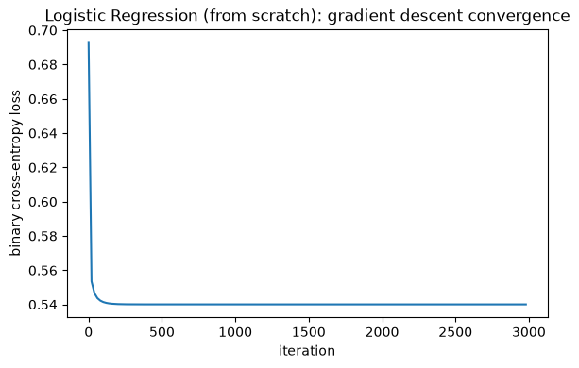
Binary cross-entropy loss vs. gradient-descent iteration.
Result
The model converged smoothly to a test accuracy of 73.00%. local_std again receives by far the largest weight magnitude, consistent with the Decision Tree result in Experiment 2.

